 |  |  |  |  |  | Optical Module Tx & Rx Summary |  |  |  |  |  |  |  |  |  |  |  |  |  |  |  |  |  |  |  |  |  |  |  |  |  |  |  |  |  |  |  |  |  | Sale dept.
 |  |  |  |  |  |  |  |  |  |  |  |  |  |  |  |  |  |  |  |  |  |  |  |  |  |  |  |  |  |  |  |  |  |  |  |  |  |  |  | K17
STANDARD TYPE Application : DVD player , Audio Equipment. |  |  |  |  |  |  |  |  |  |  |  |  |  |  |  |  |  |  |  |  |  |  |  |  |  |  |  |  |  |  |  |  |  | MINI TYPE
   |  |  |  | JST1111  JSR1111 |  |  |  |  |  |  |    |  |  | JST1151  JSR1151 |  |  |  |  | 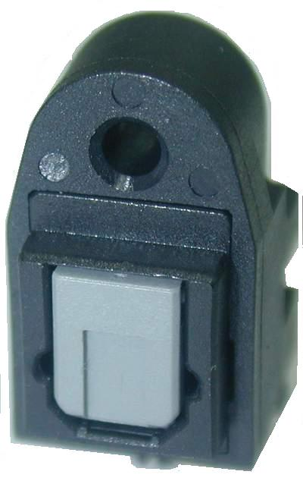 |  |  |  |  |  |  | JST1162  JSR1162 |  |  |  |  |  |  |  | 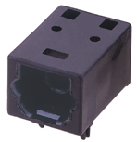 |  |  |  |  |  |  |  |  |  | JST1311  JSR1311
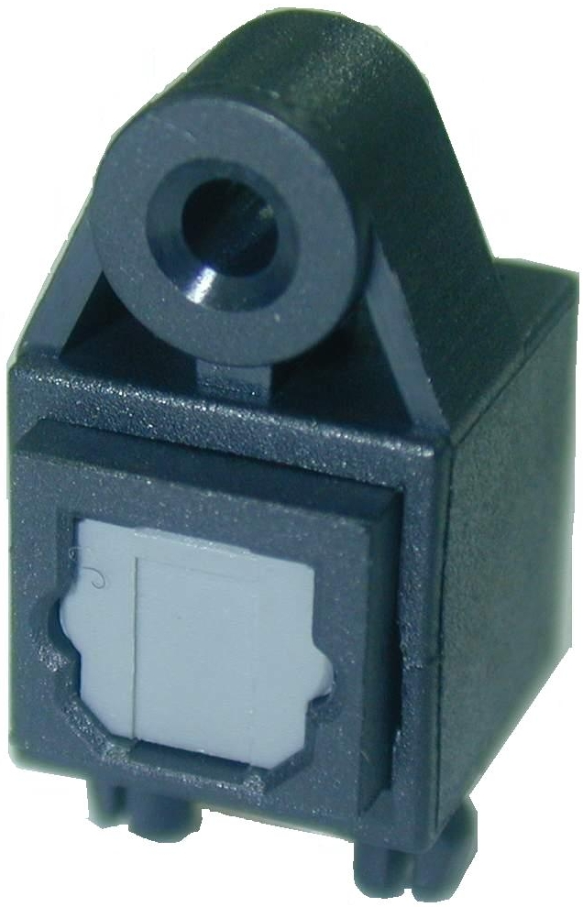 |  |  |  | JST1124  JSR1124 |  |  |  |  |  |  | 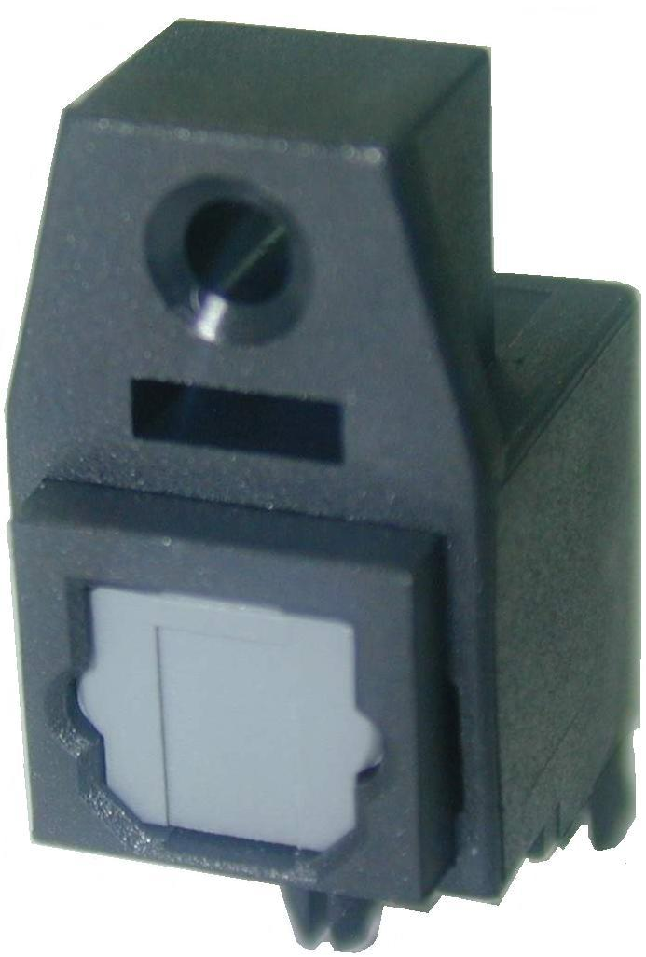 |  |  | JST1164  JSR1164 |  |  |  |  |  |  |  |  |  |  |  |  |  |  |  |  |  |  |  | 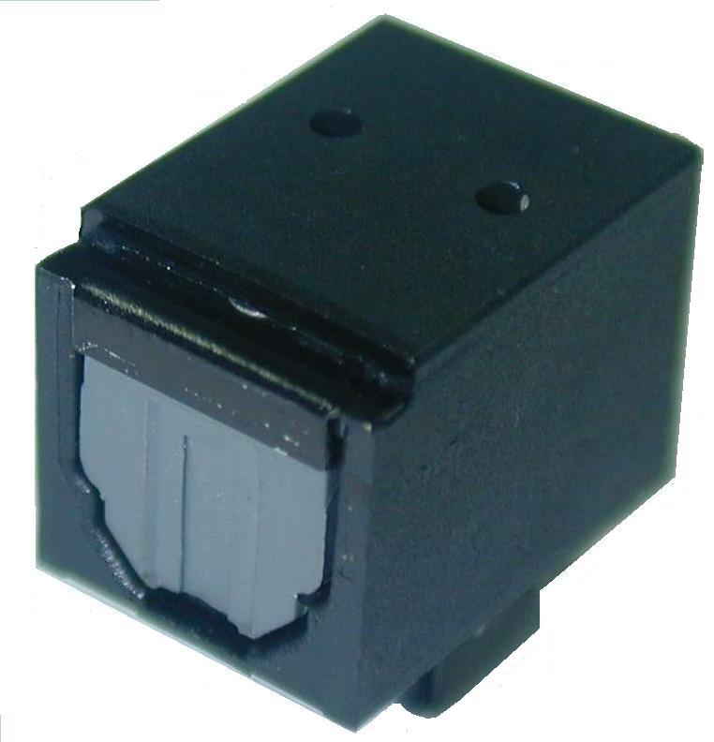 |  |  |  |  |  |  |  |  |  | JST1321  JSR1321
MEDIUM TYPE |  |  |  |  |  |  |  |  |  |  |  |  |  |  |  |  |  |  |  |  |  |  |  |  |  |  |  |  |  |  |  |  | NEW DESIGN
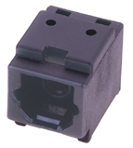 |  | JST1212  JSR1212 |  |  |  |  |  |  | 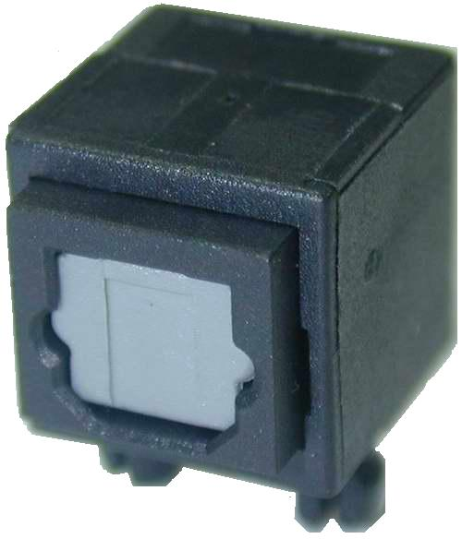 |  |  |  | JST1224  JSR1224 |  |  |  | 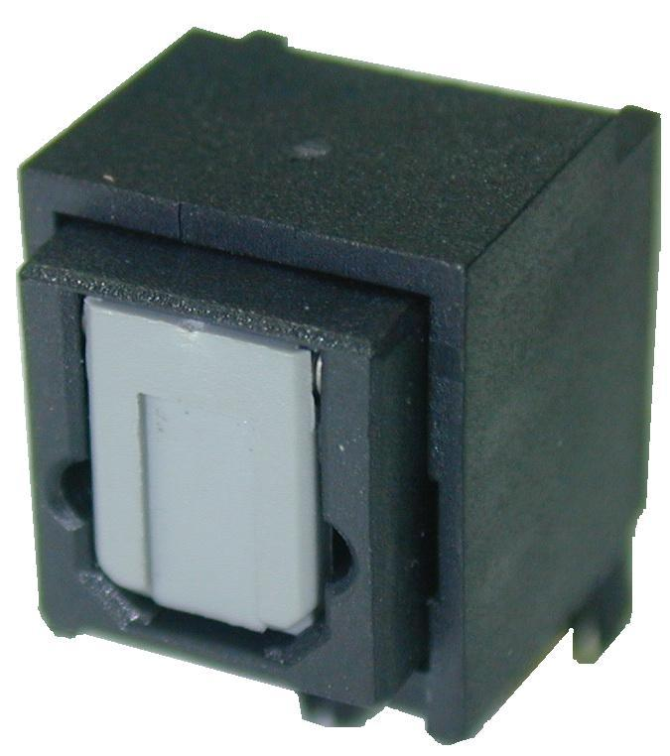 |  |  |  |  |  |  | JST1265  JSR1265 |  |  |  |  |  |  |  |  | 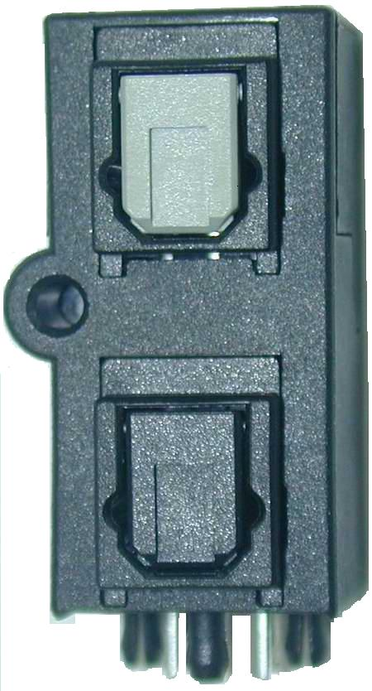 |  |  |  |  |  |  |  |  |  | JDT1661  JDR1661  JDD1661
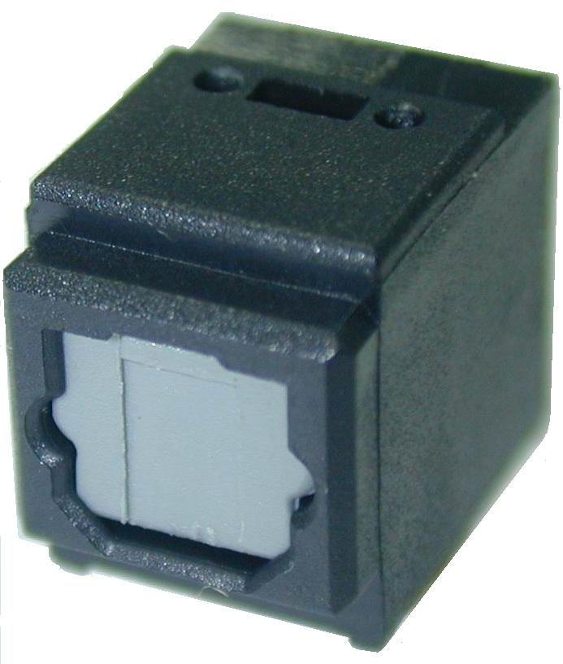 |  | JST1221  JSR1221 |  |  |  |  |  |  | 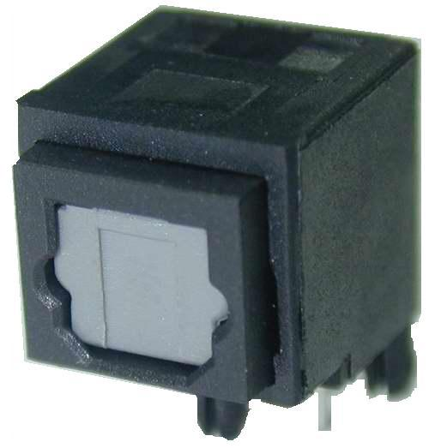 |  |  |  | JST1264  JSR1264 |  |  |  |  |  |  |  |  |  |  | JST1213  JSR1213
RCA+OPT SERIES
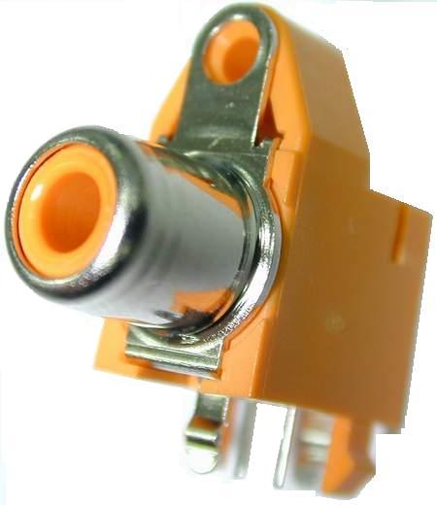 | JST1581  JSR1581 |  |  |  |  |  | 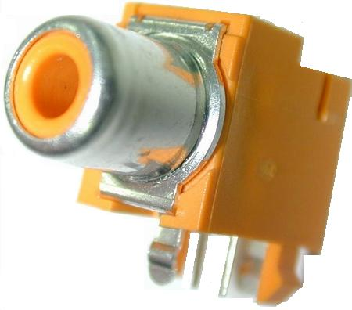 |  |  |  |  | JST1582  JSR1582 |  |  | 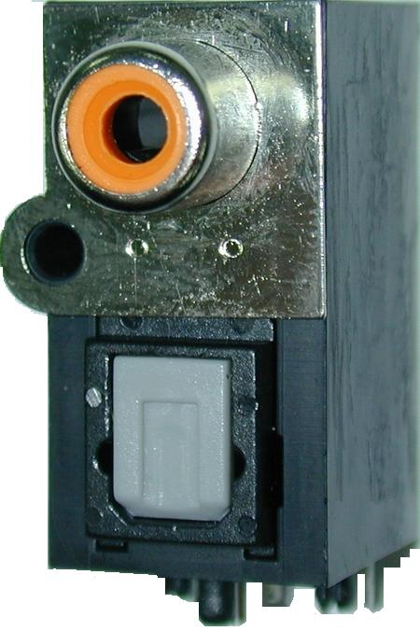 |  |  |  |  |  |  |  | JST1583  JSR1583 |  |  |  |  |  |  |  |  | 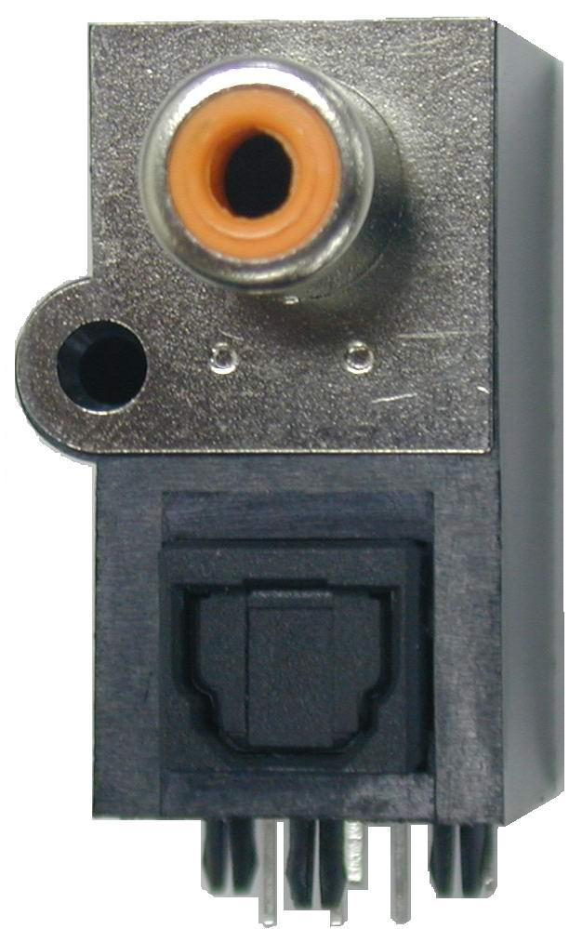 |  |  |  |  |  |  |  |  |  | JST1585  JSR1585
 | Plastic Optic Fiber |  |  |  |  |  |  |  |  |  |  |  |  |  |  | 3.5mm Type |  |  |  |  |  |  |  |  |  |  |  |  |  |  |  |  |  |  | OEM/ODM
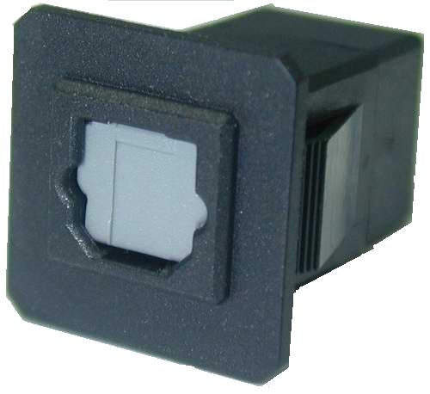  Adaptor | 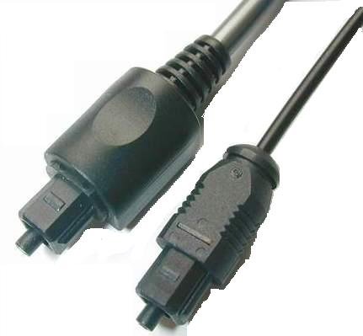 |  |  |  |  |  |  |  |  |  |  |  |  |  |  | 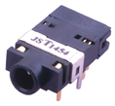  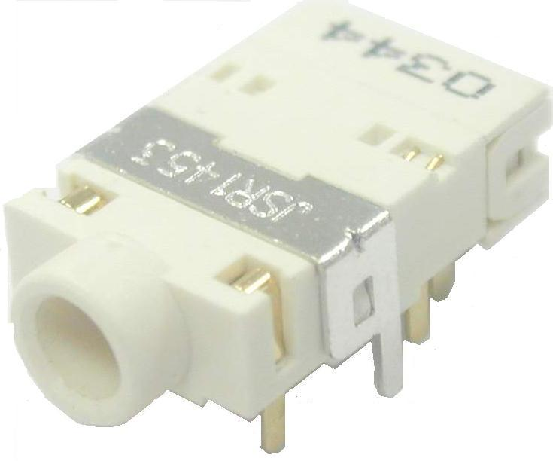 |  |  |  |  |  |  |  |  | JST1454  JSR1453 |  |  |  |  |  |  |  |  |  | 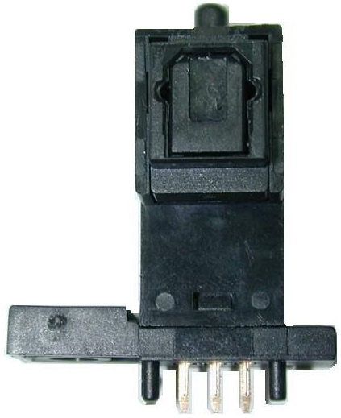  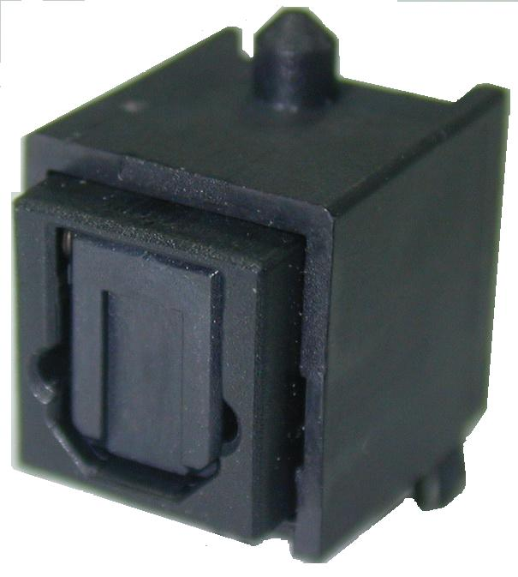
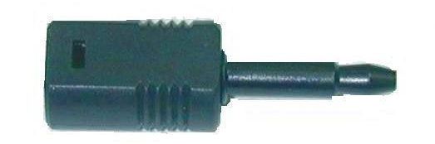 | 4.0∮ 2.2∮  3.5mm Mini Jack |  |  |  |  |  |  |  |  |  |  |  |  |  |  | 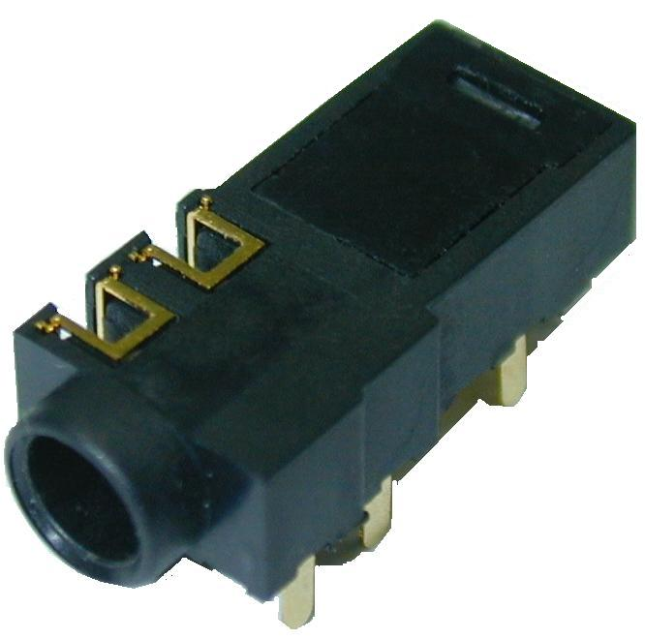  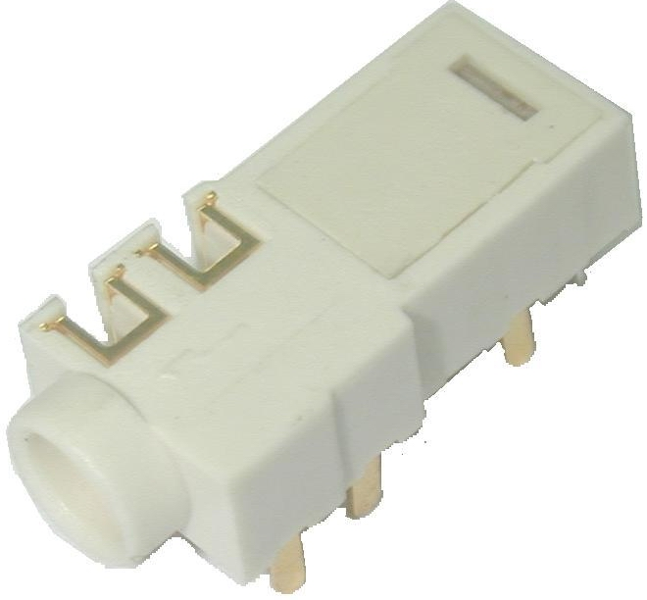 |  |  |  |  |  |  |  |  | JST3457  JSR3457
www.jeateam.com.tw 捷騰光電股份有限公司 Solteam Opto, Inc.

